**Application:** PartyGuard

**Product:** Android application

**Client:** Jacob Stansbury

**Team name:** AndroidNachos

**Team members’ roles & responsibilities:**

* Primary contact: Rakshith Anand
* Client management: Vinod Kumar Kurma
* Requirement management: Seshu Kumar
* Data management (Kinvey & REST services): Harish Yeddluri & Sridhar Yerasi
* Quality & Testing Management – Ashish Peruru
* Documentation & Communication Management – Seshu Kumar
* Issue Management – Harish Reddy Yanala

**README / Installation instructions:**

**Step-1:** Download Android Studio IDE from <https://developer.android.com/studio/index.html> into your Windows system. Launch the .exe file you downloaded. Follow the setup wizard to install Android Studio and select Android SDK in SDK tools.

**Step-2:** Our project source code is available in the CD and also in bit bucket repository, we have given you access to the repository. Clone the code to your system.

**Step-3:** Open the Android Studio IDE and go to toolbar and click on File -> open the project.

**Step-4:** Wait for some time until the project gets build. Now run the application by clicking on “Run” button in toolbar. The app runs on the emulator and you can use the app.

**Step-5:** To run the application on a mobile device, go to “Build” option and click on “Generate APK” to generate the APK file. You can see the generated APK file in the explorer. Copy that APK file to an Android device and install the app on the device and run it.

**User Manual:**

During a party at a fraternity house, if a woman faces any problem, she can report about that issue to the fraternity members. She can report about various problems like fights, someone is too drunk/sick, inappropriate behavior, and assaults of any kind. The fraternity members can view the reported notifications and they will send the rescue team to the spot. Separate to these other alerts, the emergency button feature will have a running timer and if the problem is not solved within 15 minutes an alert message will be sent to campus police.

There are 3 types of user viz. Basic user, Host user, and Guard user. Each user has their own functionality as described below.

**Basic user:** [**https://drive.google.com/open?id=0Bx9MmrMsdE2dYmJoWDFvd1B0YnM**](https://drive.google.com/open?id=0Bx9MmrMsdE2dYmJoWDFvd1B0YnM)

**Host user:** [**https://drive.google.com/open?id=0Bx9MmrMsdE2daEZaM3BDTmNzdlE**](https://drive.google.com/open?id=0Bx9MmrMsdE2daEZaM3BDTmNzdlE)

**Guard user:** [**https://drive.google.com/open?id=0Bx9MmrMsdE2dMHRCZGlDWkZIdkk**](https://drive.google.com/open?id=0Bx9MmrMsdE2dMHRCZGlDWkZIdkk)

**Code Documentation (Javadocs):**

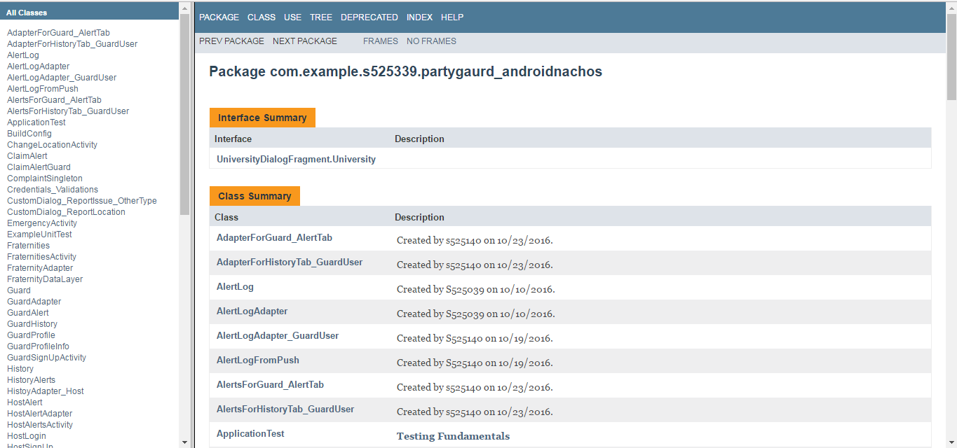

**Fig: Index showing list of all classes**

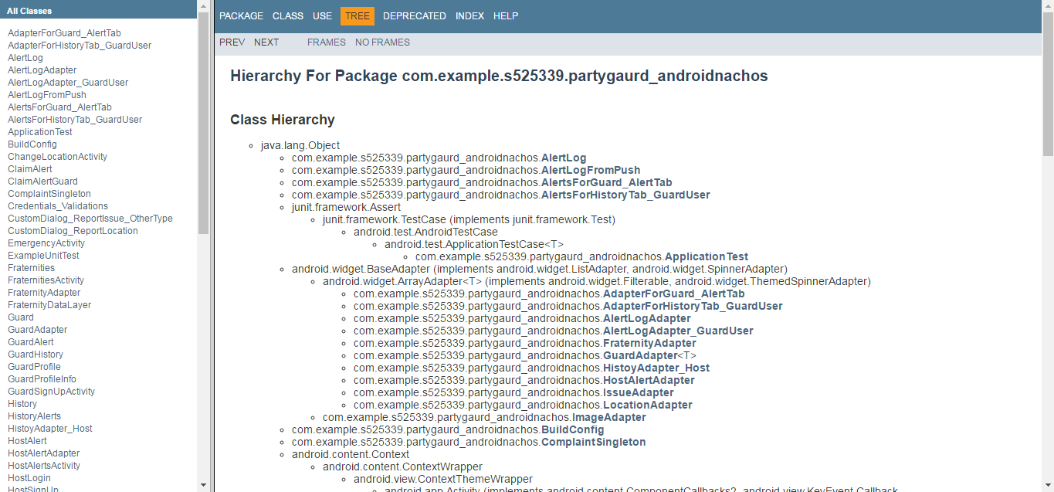

**Fig: Class hierarchy**

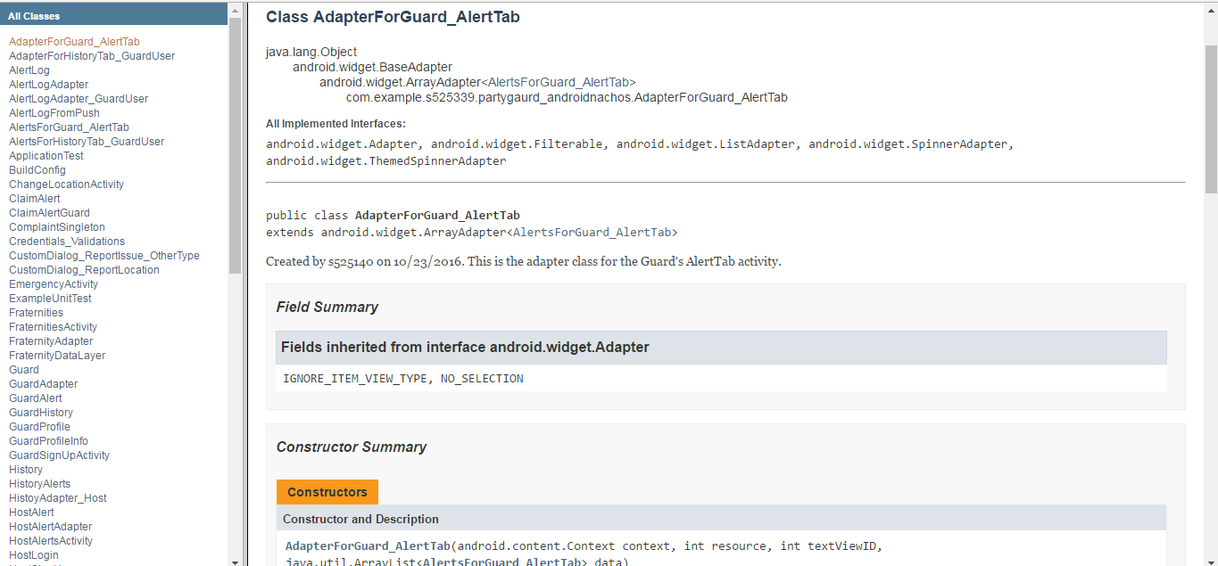

**Fig: AdapterForGuard_Alert class overview**

**Note:** We have created Javadocs for the whole project. There are61 java files in the project, it is hard to include all 61 screenshots, so we have included overview of the project. We have uploaded the Javadocs zip folder in the drive.

Javadoc’s link: <https://drive.google.com/open?id=0Bx9MmrMsdE2db2JWemlzTjZaMDQ>

**List of deliverables:**

|  |  |  |
| --- | --- | --- |
| **Artifact with link** | **Contributors** | **Contribution %** |
| [AdapterForGuard_AlertTab.java](https://bitbucket.org/gandhapuneni03/partyguard-android/src/026610708e200d1bd2078d589215bf597863e925/PartyGaurd_AndroidNachos/app/src/main/java/com/example/s525339/partygaurd_androidnachos/AdapterForGuard_AlertTab.java?at=master) | Harish Yeddluri | 100 |
| [AdapterForHistoryTab_GuardUser.java](https://bitbucket.org/gandhapuneni03/partyguard-android/src/026610708e200d1bd2078d589215bf597863e925/PartyGaurd_AndroidNachos/app/src/main/java/com/example/s525339/partygaurd_androidnachos/AdapterForHistoryTab_GuardUser.java?at=master) | Harish Yeddluri | 100 |
| [AlertLog.java](https://bitbucket.org/gandhapuneni03/partyguard-android/src/580d9e381bbf3f6b527a5df55951aa4a44791db1/PartyGaurd_AndroidNachos/app/src/main/java/com/example/s525339/partygaurd_androidnachos/AlertLog.java?at=master) | Vinod | 100 |
| [AlertLogAdapter.java](https://bitbucket.org/gandhapuneni03/partyguard-android/src/580d9e381bbf3f6b527a5df55951aa4a44791db1/PartyGaurd_AndroidNachos/app/src/main/java/com/example/s525339/partygaurd_androidnachos/AlertLogAdapter.java?at=master) | Vinod | 100 |
| [AlertLogAdapter_GuardUser.java](https://bitbucket.org/gandhapuneni03/partyguard-android/src/580d9e381bbf3f6b527a5df55951aa4a44791db1/PartyGaurd_AndroidNachos/app/src/main/java/com/example/s525339/partygaurd_androidnachos/AlertLogAdapter_GuardUser.java?at=master) | Harish Yeddluri | 100 |
| [AlertLogFromPush.java](https://bitbucket.org/gandhapuneni03/partyguard-android/src/580d9e381bbf3f6b527a5df55951aa4a44791db1/PartyGaurd_AndroidNachos/app/src/main/java/com/example/s525339/partygaurd_androidnachos/AlertLogFromPush.java?at=master) | Harish Yeddluri | 100 |
| [AlertsForGuard_AlertTab.java](https://bitbucket.org/gandhapuneni03/partyguard-android/src/026610708e200d1bd2078d589215bf597863e925/PartyGaurd_AndroidNachos/app/src/main/java/com/example/s525339/partygaurd_androidnachos/AlertsForGuard_AlertTab.java?at=master) | Harish Yeddluri | 100 |
| [AlertsForHistoryTab_GuardUser.java](https://bitbucket.org/gandhapuneni03/partyguard-android/src/026610708e200d1bd2078d589215bf597863e925/PartyGaurd_AndroidNachos/app/src/main/java/com/example/s525339/partygaurd_androidnachos/AlertsForHistoryTab_GuardUser.java?at=master) | Harish Yeddluri | 100 |
| [ChangeLocationActivity.java](https://bitbucket.org/gandhapuneni03/partyguard-android/src/580d9e381bbf3f6b527a5df55951aa4a44791db1/PartyGaurd_AndroidNachos/app/src/main/java/com/example/s525339/partygaurd_androidnachos/ChangeLocationActivity.java?at=master) | Vinod | 100 |
| [ClaimAlert.java](https://bitbucket.org/gandhapuneni03/partyguard-android/src/580d9e381bbf3f6b527a5df55951aa4a44791db1/PartyGaurd_AndroidNachos/app/src/main/java/com/example/s525339/partygaurd_androidnachos/ClaimAlert.java?at=master) | Vinod | 100 |
| [ClaimAlertGuard.java](https://bitbucket.org/gandhapuneni03/partyguard-android/src/026610708e200d1bd2078d589215bf597863e925/PartyGaurd_AndroidNachos/app/src/main/java/com/example/s525339/partygaurd_androidnachos/ClaimAlertGuard.java?at=master) | Harish Yeddluri | 100 |
| [ComplaintSingleton.java](https://bitbucket.org/gandhapuneni03/partyguard-android/src/580d9e381bbf3f6b527a5df55951aa4a44791db1/PartyGaurd_AndroidNachos/app/src/main/java/com/example/s525339/partygaurd_androidnachos/ComplaintSingleton.java?at=master) | Harish Yeddluri, Seshu | 50, 50 |
| [Credentials_Validations.java](https://bitbucket.org/gandhapuneni03/partyguard-android/src/026610708e200d1bd2078d589215bf597863e925/PartyGaurd_AndroidNachos/app/src/main/java/com/example/s525339/partygaurd_androidnachos/Credentials_Validations.java?at=master) | Vinod Kurma | 100 |
| [CustomDialog_ReportIssue_OtherType.java](https://bitbucket.org/gandhapuneni03/partyguard-android/src/580d9e381bbf3f6b527a5df55951aa4a44791db1/PartyGaurd_AndroidNachos/app/src/main/java/com/example/s525339/partygaurd_androidnachos/CustomDialog_ReportIssue_OtherType.java?at=master) | Harish Yeddluri | 100 |
| [CustomDialog_ReportLocation.java](https://bitbucket.org/gandhapuneni03/partyguard-android/src/580d9e381bbf3f6b527a5df55951aa4a44791db1/PartyGaurd_AndroidNachos/app/src/main/java/com/example/s525339/partygaurd_androidnachos/CustomDialog_ReportLocation.java?at=master) | Harish Yeddluri | 100 |
| [EmergencyActivity.java](https://bitbucket.org/gandhapuneni03/partyguard-android/src/580d9e381bbf3f6b527a5df55951aa4a44791db1/PartyGaurd_AndroidNachos/app/src/main/java/com/example/s525339/partygaurd_androidnachos/EmergencyActivity.java?at=master) | Harish Yeddluri | 100 |
| [Fraternities.java](https://bitbucket.org/gandhapuneni03/partyguard-android/src/580d9e381bbf3f6b527a5df55951aa4a44791db1/PartyGaurd_AndroidNachos/app/src/main/java/com/example/s525339/partygaurd_androidnachos/Fraternities.java?at=master) | Seshu kumar | 100 |
| [FraternitiesActivity.java](https://bitbucket.org/gandhapuneni03/partyguard-android/src/580d9e381bbf3f6b527a5df55951aa4a44791db1/PartyGaurd_AndroidNachos/app/src/main/java/com/example/s525339/partygaurd_androidnachos/FraternitiesActivity.java?at=master) | Seshu kumar | 100 |
| [FraternityAdapter.java](https://bitbucket.org/gandhapuneni03/partyguard-android/src/580d9e381bbf3f6b527a5df55951aa4a44791db1/PartyGaurd_AndroidNachos/app/src/main/java/com/example/s525339/partygaurd_androidnachos/FraternityAdapter.java?at=master) | Seshu kumar | 100 |
| [FraternityDataLayer.java](https://bitbucket.org/gandhapuneni03/partyguard-android/src/580d9e381bbf3f6b527a5df55951aa4a44791db1/PartyGaurd_AndroidNachos/app/src/main/java/com/example/s525339/partygaurd_androidnachos/FraternityDataLayer.java?at=master) | Seshu kumar | 100 |
| [Guard.java](https://bitbucket.org/gandhapuneni03/partyguard-android/src/580d9e381bbf3f6b527a5df55951aa4a44791db1/PartyGaurd_AndroidNachos/app/src/main/java/com/example/s525339/partygaurd_androidnachos/Guard.java?at=master) | Sridhar | 100 |
| [GuardAdapter.java](https://bitbucket.org/gandhapuneni03/partyguard-android/src/580d9e381bbf3f6b527a5df55951aa4a44791db1/PartyGaurd_AndroidNachos/app/src/main/java/com/example/s525339/partygaurd_androidnachos/GuardAdapter.java?at=master) | Sridhar | 100 |
| [GuardAlert.java](https://bitbucket.org/gandhapuneni03/partyguard-android/src/580d9e381bbf3f6b527a5df55951aa4a44791db1/PartyGaurd_AndroidNachos/app/src/main/java/com/example/s525339/partygaurd_androidnachos/GuardAlert.java?at=master) | Ashish | 100 |
| [GuardHistory.java](https://bitbucket.org/gandhapuneni03/partyguard-android/src/580d9e381bbf3f6b527a5df55951aa4a44791db1/PartyGaurd_AndroidNachos/app/src/main/java/com/example/s525339/partygaurd_androidnachos/GuardHistory.java?at=master) | Ashish | 100 |
| [GuardProfile.java](https://bitbucket.org/gandhapuneni03/partyguard-android/src/580d9e381bbf3f6b527a5df55951aa4a44791db1/PartyGaurd_AndroidNachos/app/src/main/java/com/example/s525339/partygaurd_androidnachos/GuardProfile.java?at=master) | Ashish | 100 |
| [GuardProfileInfo.java](https://bitbucket.org/gandhapuneni03/partyguard-android/src/580d9e381bbf3f6b527a5df55951aa4a44791db1/PartyGaurd_AndroidNachos/app/src/main/java/com/example/s525339/partygaurd_androidnachos/GuardProfileInfo.java?at=master) | Sridhar | 100 |
| [GuardSignUpActivity.java](https://bitbucket.org/gandhapuneni03/partyguard-android/src/026610708e200d1bd2078d589215bf597863e925/PartyGaurd_AndroidNachos/app/src/main/java/com/example/s525339/partygaurd_androidnachos/GuardSignUpActivity.java?at=master) | Harish Yanala | 100 |
| [History.java](https://bitbucket.org/gandhapuneni03/partyguard-android/src/580d9e381bbf3f6b527a5df55951aa4a44791db1/PartyGaurd_AndroidNachos/app/src/main/java/com/example/s525339/partygaurd_androidnachos/History.java?at=master) | Ashish | 100 |
| [HistoryAlerts.java](https://bitbucket.org/gandhapuneni03/partyguard-android/src/026610708e200d1bd2078d589215bf597863e925/PartyGaurd_AndroidNachos/app/src/main/java/com/example/s525339/partygaurd_androidnachos/HistoryAlerts.java?at=master) | Rakshith | 100 |
| [HistoyAdapter_Host.java](https://bitbucket.org/gandhapuneni03/partyguard-android/src/026610708e200d1bd2078d589215bf597863e925/PartyGaurd_AndroidNachos/app/src/main/java/com/example/s525339/partygaurd_androidnachos/HistoyAdapter_Host.java?at=master) | Rakshith | 100 |
| [HostAlert.java](https://bitbucket.org/gandhapuneni03/partyguard-android/src/580d9e381bbf3f6b527a5df55951aa4a44791db1/PartyGaurd_AndroidNachos/app/src/main/java/com/example/s525339/partygaurd_androidnachos/HostAlert.java?at=master) | Sridhar | 100 |
| [HostAlertAdapter.java](https://bitbucket.org/gandhapuneni03/partyguard-android/src/580d9e381bbf3f6b527a5df55951aa4a44791db1/PartyGaurd_AndroidNachos/app/src/main/java/com/example/s525339/partygaurd_androidnachos/HostAlertAdapter.java?at=master) | Ashish | 100 |
| [HostAlertsActivity.java](https://bitbucket.org/gandhapuneni03/partyguard-android/src/580d9e381bbf3f6b527a5df55951aa4a44791db1/PartyGaurd_AndroidNachos/app/src/main/java/com/example/s525339/partygaurd_androidnachos/HostAlertsActivity.java?at=master) | Sridhar | 100 |
| [HostLogin.java](https://bitbucket.org/gandhapuneni03/partyguard-android/src/026610708e200d1bd2078d589215bf597863e925/PartyGaurd_AndroidNachos/app/src/main/java/com/example/s525339/partygaurd_androidnachos/HostLogin.java?at=master) | Rakshith | 100 |
| [HostSignUp.java](https://bitbucket.org/gandhapuneni03/partyguard-android/src/580d9e381bbf3f6b527a5df55951aa4a44791db1/PartyGaurd_AndroidNachos/app/src/main/java/com/example/s525339/partygaurd_androidnachos/HostSignUp.java?at=master) | Vinod | 100 |
| [HostUserProfileScreen.java](https://bitbucket.org/gandhapuneni03/partyguard-android/src/580d9e381bbf3f6b527a5df55951aa4a44791db1/PartyGaurd_AndroidNachos/app/src/main/java/com/example/s525339/partygaurd_androidnachos/HostUserProfileScreen.java?at=master) | Ashish | 100 |
| [HowToUseActivity.java](https://bitbucket.org/gandhapuneni03/partyguard-android/src/580d9e381bbf3f6b527a5df55951aa4a44791db1/PartyGaurd_AndroidNachos/app/src/main/java/com/example/s525339/partygaurd_androidnachos/HowToUseActivity.java?at=master) | Harish Yanala | 100 |
| [HttpAsyncTask.java](https://bitbucket.org/gandhapuneni03/partyguard-android/src/026610708e200d1bd2078d589215bf597863e925/PartyGaurd_AndroidNachos/app/src/main/java/com/example/s525339/partygaurd_androidnachos/HttpAsyncTask.java?at=master) | Harish Yanala | 100 |
| [ImageAdapter.java](https://bitbucket.org/gandhapuneni03/partyguard-android/src/580d9e381bbf3f6b527a5df55951aa4a44791db1/PartyGaurd_AndroidNachos/app/src/main/java/com/example/s525339/partygaurd_androidnachos/ImageAdapter.java?at=master) | Sridhar | 100 |
| [IssueAdapter.java](https://bitbucket.org/gandhapuneni03/partyguard-android/src/580d9e381bbf3f6b527a5df55951aa4a44791db1/PartyGaurd_AndroidNachos/app/src/main/java/com/example/s525339/partygaurd_androidnachos/IssueAdapter.java?at=master) | Seshu | 100 |
| [Issues.java](https://bitbucket.org/gandhapuneni03/partyguard-android/src/580d9e381bbf3f6b527a5df55951aa4a44791db1/PartyGaurd_AndroidNachos/app/src/main/java/com/example/s525339/partygaurd_androidnachos/Issues.java?at=master) | Seshu | 100 |
| [LocationActivity.java](https://bitbucket.org/gandhapuneni03/partyguard-android/src/580d9e381bbf3f6b527a5df55951aa4a44791db1/PartyGaurd_AndroidNachos/app/src/main/java/com/example/s525339/partygaurd_androidnachos/LocationActivity.java?at=master) | Harish Yeddluri | 100 |
| [LocationAdapter.java](https://bitbucket.org/gandhapuneni03/partyguard-android/src/580d9e381bbf3f6b527a5df55951aa4a44791db1/PartyGaurd_AndroidNachos/app/src/main/java/com/example/s525339/partygaurd_androidnachos/LocationAdapter.java?at=master) | Harish Yeddluri | 100 |
| [Locations.java](https://bitbucket.org/gandhapuneni03/partyguard-android/src/580d9e381bbf3f6b527a5df55951aa4a44791db1/PartyGaurd_AndroidNachos/app/src/main/java/com/example/s525339/partygaurd_androidnachos/Locations.java?at=master) | Harish Yeddluri | 100 |
| [LoginActivity.java](https://bitbucket.org/gandhapuneni03/partyguard-android/src/580d9e381bbf3f6b527a5df55951aa4a44791db1/PartyGaurd_AndroidNachos/app/src/main/java/com/example/s525339/partygaurd_androidnachos/LoginActivity.java?at=master) | Rakshith Anand | 100 |
| [MainActivity.java](https://bitbucket.org/gandhapuneni03/partyguard-android/src/580d9e381bbf3f6b527a5df55951aa4a44791db1/PartyGaurd_AndroidNachos/app/src/main/java/com/example/s525339/partygaurd_androidnachos/MainActivity.java?at=master) | All | 100 |
| [PgteamActivity.java](https://bitbucket.org/gandhapuneni03/partyguard-android/src/580d9e381bbf3f6b527a5df55951aa4a44791db1/PartyGaurd_AndroidNachos/app/src/main/java/com/example/s525339/partygaurd_androidnachos/PgteamActivity.java?at=master) | Sridhar | 100 |
| [PrefManager.java](https://bitbucket.org/gandhapuneni03/partyguard-android/src/580d9e381bbf3f6b527a5df55951aa4a44791db1/PartyGaurd_AndroidNachos/app/src/main/java/com/example/s525339/partygaurd_androidnachos/PrefManager.java?at=master) | Harish Yanala | 100 |
| [ProfileDropDownMenu.java](https://bitbucket.org/gandhapuneni03/partyguard-android/src/580d9e381bbf3f6b527a5df55951aa4a44791db1/PartyGaurd_AndroidNachos/app/src/main/java/com/example/s525339/partygaurd_androidnachos/ProfileDropDownMenu.java?at=master) | Vinod | 100 |
| [ReportIssueActivity.java](https://bitbucket.org/gandhapuneni03/partyguard-android/src/580d9e381bbf3f6b527a5df55951aa4a44791db1/PartyGaurd_AndroidNachos/app/src/main/java/com/example/s525339/partygaurd_androidnachos/ReportIssueActivity.java?at=master) | Seshu | 100 |
| [ResetPasswordActivity.java](https://bitbucket.org/gandhapuneni03/partyguard-android/src/580d9e381bbf3f6b527a5df55951aa4a44791db1/PartyGaurd_AndroidNachos/app/src/main/java/com/example/s525339/partygaurd_androidnachos/ResetPasswordActivity.java?at=master) | Harish Yanala | 100 |
| [SampleActivity_ForAPI.java](https://bitbucket.org/gandhapuneni03/partyguard-android/src/580d9e381bbf3f6b527a5df55951aa4a44791db1/PartyGaurd_AndroidNachos/app/src/main/java/com/example/s525339/partygaurd_androidnachos/SampleActivity_ForAPI.java?at=master) | Harish Yeddluri | 100 |
| [SavedSharedPreference.java](https://bitbucket.org/gandhapuneni03/partyguard-android/src/580d9e381bbf3f6b527a5df55951aa4a44791db1/PartyGaurd_AndroidNachos/app/src/main/java/com/example/s525339/partygaurd_androidnachos/SavedSharedPreference.java?at=master) | Rakshith Anand | 100 |
| [SignUpActivity.java](https://bitbucket.org/gandhapuneni03/partyguard-android/src/580d9e381bbf3f6b527a5df55951aa4a44791db1/PartyGaurd_AndroidNachos/app/src/main/java/com/example/s525339/partygaurd_androidnachos/SignUpActivity.java?at=master) | Rakshith Anand | 100 |
| [UniversityActivity.java](https://bitbucket.org/gandhapuneni03/partyguard-android/src/580d9e381bbf3f6b527a5df55951aa4a44791db1/PartyGaurd_AndroidNachos/app/src/main/java/com/example/s525339/partygaurd_androidnachos/UniversityActivity.java?at=master) | Seshu | 100 |
| [UniversityDialogFragment.java](https://bitbucket.org/gandhapuneni03/partyguard-android/src/580d9e381bbf3f6b527a5df55951aa4a44791db1/PartyGaurd_AndroidNachos/app/src/main/java/com/example/s525339/partygaurd_androidnachos/UniversityDialogFragment.java?at=master) | Seshu | 100 |
| [UserData_Login.java](https://bitbucket.org/gandhapuneni03/partyguard-android/src/580d9e381bbf3f6b527a5df55951aa4a44791db1/PartyGaurd_AndroidNachos/app/src/main/java/com/example/s525339/partygaurd_androidnachos/UserData_Login.java?at=master) | Rakshith Anand | 100 |
| [UserInformation.java](https://bitbucket.org/gandhapuneni03/partyguard-android/src/580d9e381bbf3f6b527a5df55951aa4a44791db1/PartyGaurd_AndroidNachos/app/src/main/java/com/example/s525339/partygaurd_androidnachos/UserInformation.java?at=master) | Vinod | 100 |
| [UserLogActivity.java](https://bitbucket.org/gandhapuneni03/partyguard-android/src/580d9e381bbf3f6b527a5df55951aa4a44791db1/PartyGaurd_AndroidNachos/app/src/main/java/com/example/s525339/partygaurd_androidnachos/UserLogActivity.java?at=master) | Vinod | 100 |
| [UserSettings.java](https://bitbucket.org/gandhapuneni03/partyguard-android/src/580d9e381bbf3f6b527a5df55951aa4a44791db1/PartyGaurd_AndroidNachos/app/src/main/java/com/example/s525339/partygaurd_androidnachos/UserSettings.java?at=master) | Vinod | 100 |
| [Utility.java](https://bitbucket.org/gandhapuneni03/partyguard-android/src/580d9e381bbf3f6b527a5df55951aa4a44791db1/PartyGaurd_AndroidNachos/app/src/main/java/com/example/s525339/partygaurd_androidnachos/Utility.java?at=master) | Ashish | 100 |
| [AndroidManifest.xml](https://bitbucket.org/gandhapuneni03/partyguard-android/src/580d9e381bbf3f6b527a5df55951aa4a44791db1/PartyGaurd_AndroidNachos/app/src/main/AndroidManifest.xml?at=master) | All | 100 |
| [action_bar.xml](https://bitbucket.org/gandhapuneni03/partyguard-android/src/580d9e381bbf3f6b527a5df55951aa4a44791db1/PartyGaurd_AndroidNachos/app/src/main/res/layout/action_bar.xml?at=master) | Seshu | 100 |
| [activity_alert.xml](https://bitbucket.org/gandhapuneni03/partyguard-android/src/580d9e381bbf3f6b527a5df55951aa4a44791db1/PartyGaurd_AndroidNachos/app/src/main/res/layout/activity_alert.xml?at=master) | Vinod | 100 |
| [activity_change_location.xml](https://bitbucket.org/gandhapuneni03/partyguard-android/src/580d9e381bbf3f6b527a5df55951aa4a44791db1/PartyGaurd_AndroidNachos/app/src/main/res/layout/activity_change_location.xml?at=master) | Vinod | 100 |
| [activity_claim_alert.xml](https://bitbucket.org/gandhapuneni03/partyguard-android/src/580d9e381bbf3f6b527a5df55951aa4a44791db1/PartyGaurd_AndroidNachos/app/src/main/res/layout/activity_claim_alert.xml?at=master) | Vinod | 100 |
| [activity_custom_dialog__report_issue__other_type.xml](https://bitbucket.org/gandhapuneni03/partyguard-android/src/580d9e381bbf3f6b527a5df55951aa4a44791db1/PartyGaurd_AndroidNachos/app/src/main/res/layout/activity_custom_dialog__report_issue__other_type.xml?at=master) | Harish Yeddluri | 100 |
| [activity_custom_dialog__report_location.xml](https://bitbucket.org/gandhapuneni03/partyguard-android/src/580d9e381bbf3f6b527a5df55951aa4a44791db1/PartyGaurd_AndroidNachos/app/src/main/res/layout/activity_custom_dialog__report_location.xml?at=master) | Harish Yeddluri | 100 |
| [activity_emergency.xml](https://bitbucket.org/gandhapuneni03/partyguard-android/src/580d9e381bbf3f6b527a5df55951aa4a44791db1/PartyGaurd_AndroidNachos/app/src/main/res/layout/activity_emergency.xml?at=master) | Harish Yeddluri | 100 |
| [activity_fraternities.xml](https://bitbucket.org/gandhapuneni03/partyguard-android/src/580d9e381bbf3f6b527a5df55951aa4a44791db1/PartyGaurd_AndroidNachos/app/src/main/res/layout/activity_fraternities.xml?at=master) | Seshu | 100 |
| [activity_guard_alert.xml](https://bitbucket.org/gandhapuneni03/partyguard-android/src/580d9e381bbf3f6b527a5df55951aa4a44791db1/PartyGaurd_AndroidNachos/app/src/main/res/layout/activity_guard_alert.xml?at=master) | Ashish | 100 |
| [activity_guard_history.xml](https://bitbucket.org/gandhapuneni03/partyguard-android/src/580d9e381bbf3f6b527a5df55951aa4a44791db1/PartyGaurd_AndroidNachos/app/src/main/res/layout/activity_guard_history.xml?at=master) | Ashish | 100 |
| [activity_guard_profile.xml](https://bitbucket.org/gandhapuneni03/partyguard-android/src/580d9e381bbf3f6b527a5df55951aa4a44791db1/PartyGaurd_AndroidNachos/app/src/main/res/layout/activity_guard_profile.xml?at=master) | Ashish | 100 |
| [activity_guard_profile_info.xml](https://bitbucket.org/gandhapuneni03/partyguard-android/src/580d9e381bbf3f6b527a5df55951aa4a44791db1/PartyGaurd_AndroidNachos/app/src/main/res/layout/activity_guard_profile_info.xml?at=master) | Ashish | 100 |
| [activity_history.xml](https://bitbucket.org/gandhapuneni03/partyguard-android/src/580d9e381bbf3f6b527a5df55951aa4a44791db1/PartyGaurd_AndroidNachos/app/src/main/res/layout/activity_history.xml?at=master) | Ashish | 100 |
| [activity_host_login.xml](https://bitbucket.org/gandhapuneni03/partyguard-android/src/580d9e381bbf3f6b527a5df55951aa4a44791db1/PartyGaurd_AndroidNachos/app/src/main/res/layout/activity_host_login.xml?at=master) | Vinod | 100 |
| [activity_host_sign_up.xml](https://bitbucket.org/gandhapuneni03/partyguard-android/src/580d9e381bbf3f6b527a5df55951aa4a44791db1/PartyGaurd_AndroidNachos/app/src/main/res/layout/activity_host_sign_up.xml?at=master) | Vinod | 100 |
| [activity_host_user_profile_screen.xml](https://bitbucket.org/gandhapuneni03/partyguard-android/src/580d9e381bbf3f6b527a5df55951aa4a44791db1/PartyGaurd_AndroidNachos/app/src/main/res/layout/activity_host_user_profile_screen.xml?at=master) | Ashish | 100 |
| [activity_how_to_use.xml](https://bitbucket.org/gandhapuneni03/partyguard-android/src/580d9e381bbf3f6b527a5df55951aa4a44791db1/PartyGaurd_AndroidNachos/app/src/main/res/layout/activity_how_to_use.xml?at=master) | Harish Yanala | 100 |
| [activity_location.xml](https://bitbucket.org/gandhapuneni03/partyguard-android/src/580d9e381bbf3f6b527a5df55951aa4a44791db1/PartyGaurd_AndroidNachos/app/src/main/res/layout/activity_location.xml?at=master) | Harish Yeddluri | 100 |
| [activity_login.xml](https://bitbucket.org/gandhapuneni03/partyguard-android/src/580d9e381bbf3f6b527a5df55951aa4a44791db1/PartyGaurd_AndroidNachos/app/src/main/res/layout/activity_login.xml?at=master) | Rakshith Anand | 100 |
| [activity_main.xml](https://bitbucket.org/gandhapuneni03/partyguard-android/src/580d9e381bbf3f6b527a5df55951aa4a44791db1/PartyGaurd_AndroidNachos/app/src/main/res/layout/activity_main.xml?at=master) | All | 100 |
| [activity_pgteam.xml](https://bitbucket.org/gandhapuneni03/partyguard-android/src/580d9e381bbf3f6b527a5df55951aa4a44791db1/PartyGaurd_AndroidNachos/app/src/main/res/layout/activity_pgteam.xml?at=master) | Sridhar | 100 |
| [activity_profile_drop_down_menu.xml](https://bitbucket.org/gandhapuneni03/partyguard-android/src/580d9e381bbf3f6b527a5df55951aa4a44791db1/PartyGaurd_AndroidNachos/app/src/main/res/layout/activity_profile_drop_down_menu.xml?at=master) | Vinod | 100 |
| [activity_report_issue.xml](https://bitbucket.org/gandhapuneni03/partyguard-android/src/580d9e381bbf3f6b527a5df55951aa4a44791db1/PartyGaurd_AndroidNachos/app/src/main/res/layout/activity_report_issue.xml?at=master) | Seshu | 100 |
| [activity_reset_password.xml](https://bitbucket.org/gandhapuneni03/partyguard-android/src/580d9e381bbf3f6b527a5df55951aa4a44791db1/PartyGaurd_AndroidNachos/app/src/main/res/layout/activity_reset_password.xml?at=master) | Harish Yanala | 100 |
| [activity_sample_activity__for_api.xml](https://bitbucket.org/gandhapuneni03/partyguard-android/src/580d9e381bbf3f6b527a5df55951aa4a44791db1/PartyGaurd_AndroidNachos/app/src/main/res/layout/activity_sample_activity__for_api.xml?at=master) | Harish Yeddluri | 100 |
| [activity_sign_up.xml](https://bitbucket.org/gandhapuneni03/partyguard-android/src/580d9e381bbf3f6b527a5df55951aa4a44791db1/PartyGaurd_AndroidNachos/app/src/main/res/layout/activity_sign_up.xml?at=master) | Rakshith Anand | 100 |
| [activity_university.xml](https://bitbucket.org/gandhapuneni03/partyguard-android/src/580d9e381bbf3f6b527a5df55951aa4a44791db1/PartyGaurd_AndroidNachos/app/src/main/res/layout/activity_university.xml?at=master) | Seshu | 100 |
| [activity_user_information.xml](https://bitbucket.org/gandhapuneni03/partyguard-android/src/580d9e381bbf3f6b527a5df55951aa4a44791db1/PartyGaurd_AndroidNachos/app/src/main/res/layout/activity_user_information.xml?at=master) | Vinod | 100 |
| [activity_user_log.xml](https://bitbucket.org/gandhapuneni03/partyguard-android/src/580d9e381bbf3f6b527a5df55951aa4a44791db1/PartyGaurd_AndroidNachos/app/src/main/res/layout/activity_user_log.xml?at=master) | Vinod | 100 |
| [activity_user_settings.xml](https://bitbucket.org/gandhapuneni03/partyguard-android/src/580d9e381bbf3f6b527a5df55951aa4a44791db1/PartyGaurd_AndroidNachos/app/src/main/res/layout/activity_user_settings.xml?at=master) | Vinod | 100 |
| [alert_log_list_iten_guard_user.xml](https://bitbucket.org/gandhapuneni03/partyguard-android/src/580d9e381bbf3f6b527a5df55951aa4a44791db1/PartyGaurd_AndroidNachos/app/src/main/res/layout/alert_log_list_iten_guard_user.xml?at=master) | Harish Yeddluri | 100 |
| [alertlog_listitem.xml](https://bitbucket.org/gandhapuneni03/partyguard-android/src/580d9e381bbf3f6b527a5df55951aa4a44791db1/PartyGaurd_AndroidNachos/app/src/main/res/layout/alertlog_listitem.xml?at=master) | Sridhar | 100 |
| [app_bar_profile_drop_down_menu.xml](https://bitbucket.org/gandhapuneni03/partyguard-android/src/580d9e381bbf3f6b527a5df55951aa4a44791db1/PartyGaurd_AndroidNachos/app/src/main/res/layout/app_bar_profile_drop_down_menu.xml?at=master) | Vinod | 100 |
| [content_profile_drop_down_menu.xml](https://bitbucket.org/gandhapuneni03/partyguard-android/src/580d9e381bbf3f6b527a5df55951aa4a44791db1/PartyGaurd_AndroidNachos/app/src/main/res/layout/content_profile_drop_down_menu.xml?at=master) | Vinod | 100 |
| [fraternity_list_item_menu.xml](https://bitbucket.org/gandhapuneni03/partyguard-android/src/580d9e381bbf3f6b527a5df55951aa4a44791db1/PartyGaurd_AndroidNachos/app/src/main/res/layout/fraternity_list_item_menu.xml?at=master) | Seshu | 100 |
| [host_alert_list_item_menu.xml](https://bitbucket.org/gandhapuneni03/partyguard-android/src/580d9e381bbf3f6b527a5df55951aa4a44791db1/PartyGaurd_AndroidNachos/app/src/main/res/layout/host_alert_list_item_menu.xml?at=master) | Sridhar | 100 |
| [location_list_item.xml](https://bitbucket.org/gandhapuneni03/partyguard-android/src/580d9e381bbf3f6b527a5df55951aa4a44791db1/PartyGaurd_AndroidNachos/app/src/main/res/layout/location_list_item.xml?at=master) | Harish Yeddluri | 100 |
| [nav_header_profile_drop_down_menu.xml](https://bitbucket.org/gandhapuneni03/partyguard-android/src/580d9e381bbf3f6b527a5df55951aa4a44791db1/PartyGaurd_AndroidNachos/app/src/main/res/layout/nav_header_profile_drop_down_menu.xml?at=master) | Vinod | 100 |
| [pgteam_griditem.xml](https://bitbucket.org/gandhapuneni03/partyguard-android/src/580d9e381bbf3f6b527a5df55951aa4a44791db1/PartyGaurd_AndroidNachos/app/src/main/res/layout/pgteam_griditem.xml?at=master) | Sridhar | 100 |
| [university_list_item.xml](https://bitbucket.org/gandhapuneni03/partyguard-android/src/580d9e381bbf3f6b527a5df55951aa4a44791db1/PartyGaurd_AndroidNachos/app/src/main/res/layout/university_list_item.xml?at=master) | Seshu Kumar | 100 |
| [welcome_slide1.xml](https://bitbucket.org/gandhapuneni03/partyguard-android/src/580d9e381bbf3f6b527a5df55951aa4a44791db1/PartyGaurd_AndroidNachos/app/src/main/res/layout/welcome_slide1.xml?at=master) | Harish Yanala | 100 |
| [welcome_slide2.xml](https://bitbucket.org/gandhapuneni03/partyguard-android/src/580d9e381bbf3f6b527a5df55951aa4a44791db1/PartyGaurd_AndroidNachos/app/src/main/res/layout/welcome_slide2.xml?at=master) | Harish Yanala | 100 |
| [welcome_slide3.xml](https://bitbucket.org/gandhapuneni03/partyguard-android/src/580d9e381bbf3f6b527a5df55951aa4a44791db1/PartyGaurd_AndroidNachos/app/src/main/res/layout/welcome_slide3.xml?at=master) | Harish Yanala | 100 |
| [Cross Team Testing.doc](https://bitbucket.org/gandhapuneni03/partyguard-android/src/e78c3bd29bec230120ed9dd7c91a12bf7975848b/Docs/usability/Cross%20Team%20Testing.doc?at=master) | Vinod Kurma, Ashish Peruru | 50,50 |
| Client acceptance test report | Vinod Kurma, Harish Yeddluri | 50,50 |
| [MoM Client Meeting--Latest.docx](https://bitbucket.org/gandhapuneni03/partyguard-android/src/026610708e200d1bd2078d589215bf597863e925/Docs/client/MoM%20Client%20Meeting--Latest.docx?at=master) | Vinod Kurma | 100 |
| [SystemDescription_AndroidNachos_PartyGuard_v0.1--Latest.docx](https://bitbucket.org/gandhapuneni03/partyguard-android/src/026610708e200d1bd2078d589215bf597863e925/Docs/client/SystemDescription_AndroidNachos_PartyGuard_v0.1--Latest.docx?at=master) | Seshu Kumar | 100 |
| [AppData - PartyGuard.xlsx](https://bitbucket.org/gandhapuneni03/partyguard-android/src/026610708e200d1bd2078d589215bf597863e925/Docs/data/AppData%20-%20PartyGuard.xlsx?at=master) | Seshu Kumar | 100 |
| [BasicUserManual.docx](https://bitbucket.org/gandhapuneni03/partyguard-android/src/026610708e200d1bd2078d589215bf597863e925/Docs/guides/BasicUserManual.docx?at=master) | Harish Yanala | 100 |
| [GuardUserManual.docx](https://bitbucket.org/gandhapuneni03/partyguard-android/src/026610708e200d1bd2078d589215bf597863e925/Docs/guides/GuardUserManual.docx?at=master) | Ashish Peruru | 100 |
| [HostUserManual.docx](https://bitbucket.org/gandhapuneni03/partyguard-android/src/026610708e200d1bd2078d589215bf597863e925/Docs/guides/HostUserManual.docx?at=master) | Rakshith | 100 |
| [User Interface--Latest.docx](https://bitbucket.org/gandhapuneni03/partyguard-android/src/026610708e200d1bd2078d589215bf597863e925/Docs/ui/User%20Interface--Latest.docx?at=master) | Harish Yeddluri | 100 |
| User documentation  <https://drive.google.com/open?id=0Bx9MmrMsdE2dQmRTcHFPVkZYT2c> | Harish Yanala, Rakshith | 60, 40 |